SMART LOGISTICS ANALYTICS SYSTEM

What our project actual is:
Our project, Smart Logistics Analytics System, is about analyzing real government road transport data to understand how freight (goods movement) and passenger transport in India have grown over time, studying their trends, growth rates, and relationships with economic factors, and then building a predictive model to forecast future transport demand. Throughout the project, we will collect and clean datasets, perform exploratory data analysis using graphs and statistical measures, compare freight and passenger patterns, examine correlations, analyze toll revenue impact, and finally use forecasting techniques to predict upcoming logistics demand so that the system can support smarter infrastructure planning and decision-making.

Phase 1: Problem Understanding:

What problem are we solving?
India’s road transport sector is continuously growing.
But decision-makers need answers like:
- Is freight increasing steadily?
- Is passenger demand stable?
- How fast is growth happening?
- What patterns can we observe?
Our system will:
Analyze historical road transport data and generate insights that help in logistics planning.
Stage 1: Dataset Selection (Why these datasets?)
For Mid-Term, we will mainly use:

Dataset 1 (Core Dataset)
Year-wise Freight & Passenger Movement (1999–2000 to 2019–20)
Columns:
- Year
- Freight (Billion Tonne-Km)
- Passenger (Billion Passenger-Km)
- GDP Growth Rate

Why we are using this dataset?
Because:
- It directly represents logistics activity.
- Freight = goods movement.
- Passenger = mobility demand.
- GDP = economic indicator.
This dataset helps us analyze logistics growth patterns. This is our main dataset for mid-term.
Stage 2: Environment Setup & Data Loading

We will be using Google Colab and build a new notebook.

Step 1: Import Required Libraries

import pandas as pd
import matplotlib.pyplot as plt

Why?
Pandas – for handling dataset
Matplotlib – for visualization

Step 2: Load the Dataset

df = pd.read_csv("/content/RTYB201920_A1_6.csv")

Why?
This loads our logistics dataset into memory so we can analyze it. Without this dataset, the system cannot analyze or predict anything.

Step 3: View Basic Information

df.head() # Views first 5 rows

Output:

 | Year | Freight (Billion Tonnes km) | Passenger (Billion Passengers km) | GDP Growth Rate used
0 | 1999-2000 | 467.0 | 1832 | 0.080
1 | 2000-01 | 494.0 | 2076 | 0.041
2 | 2001-02 | 515.0 | 2413 | 0.054
3 | 2002-03 | 545.0 | 2815 | 0.039
4 | 2003-04 | 595.0 | 3070 | 0.080

Purpose:
See first 5 rows
Understand structure

df.shape # Check number of rows and columns

Output:

(21, 4)

Purpose:
Check number of rows and columns
Expected:
21 rows, 4 columns

df.info() # Check data types, missing values

Output:

<class 'pandas.core.frame.DataFrame'>
RangeIndex: 21 entries, 0 to 20
Data columns (total 4 columns):
# Column Non-Null Count Dtype
--- ------ -------------- -----
0 Year 21 non-null object
1 Freight (Billion Tonnes km) 21 non-null float64
2 Passenger (Billion Passengers km) 21 non-null int64
3 GDP Growth Rate used 21 non-null float64
dtypes: float64(2), int64(1), object(1)
memory usage: 804.0+ bytes
Purpose:
Check data types; here Year is presented as object(string type)
Check missing values

df.describe() # Get Statistical summary

Output:

 | Freight (Billion Tonnes km) | Passenger (Billion Passengers km) | GDP Growth Rate used
count | 21.000000 | 21.000000 | 21.000000
mean | 1333.290476 | 9439.904762 | 0.071714
std | 779.064572 | 7177.001525 | 0.016386
min | 467.000000 | 1832.000000 | 0.039000
25% | 643.000000 | 3469.000000 | 0.061000
50% | 1144.500000 | 7192.000000 | 0.071000
75% | 1823.200000 | 13393.000000 | 0.083000
max | 2927.300000 | 25199.000000 | 0.096000

Purpose:
Get statistical summary
Mean, min, max, standard deviation
For example:
Freight:
- Minimum ≈ 467
- Maximum ≈ higher in later years
This tells you:
- Freight has significantly increased over time.
- Passenger movement also shows wide range.
- Growth is substantial.
It confirms upward expansion.
Stage 3: Data Cleaning and Preprocessing

Raw government data is usually not clean. We now make it machine-friendly.

Step 4: Rename Columns

df.columns = [
"year",
"freight_billion_tkm",
"passenger_billion_pkm",
"gdp_growth_rate"
]

Why?
Remove spaces and special characters
Make column names clean and usable
This is a professional practice.

Step 5: Fix Year Column

Since year appears as :1999-2000 , therefore we need to convert to numeric format.

df["year"] = df["year"].astype(str)
df["year"] = df["year"].str[:4]
df["year"] = pd.to_numeric(df["year"])

Why?
Extract first 4 digits -> 1999
Convert to numeric
Makes it usable for plotting and modelling

Now “year” is numeric.
Why important?
Because:
- Graph x-axis needs numbers
- Regression models need numbers
- Time series needs numeric values
This step makes data usable for analytics.
This means:
If any value cannot be converted to a number,
Replace it with NaN (missing value).
Output:

df.head()

 | year | freight_billion_tkm | passenger_billion_pkm | gdp_growth_rate
0 | 1999 | 467.0 | 1832 | 0.080
1 | 2000 | 494.0 | 2076 | 0.041
2 | 2001 | 515.0 | 2413 | 0.054
3 | 2002 | 545.0 | 2815 | 0.039
4 | 2003 | 595.0 | 3070 | 0.080

Step 6: Check Missing Values

df.isnull().sum()

Expected: All zeros
Why?
Missing values can affect analysis.
If zero -> dataset is clean.

Output:

 | 0
year | 0
freight_billion_tkm | 0
passenger_billion_pkm | 0
gdp_growth_rate | 0
dtype: int64

Stage 4: Exploratory Data Analysis (EDA)

Now we analyze logistics growth patterns.
This is the main part.

Step 7: Freight Trend Analysis

# # Exploratory Data Analysis
# Freight Movement over time
plt.figure(figsize=(10,6))
plt.plot(df["year"], df["freight_billion_tkm"])
plt.xlabel("Year")
plt.ylabel("Freight (Billion Tonne-Km)")
plt.title("Year-wise Freight Movement Growth")
plt.grid(True)
plt.show()

Output:

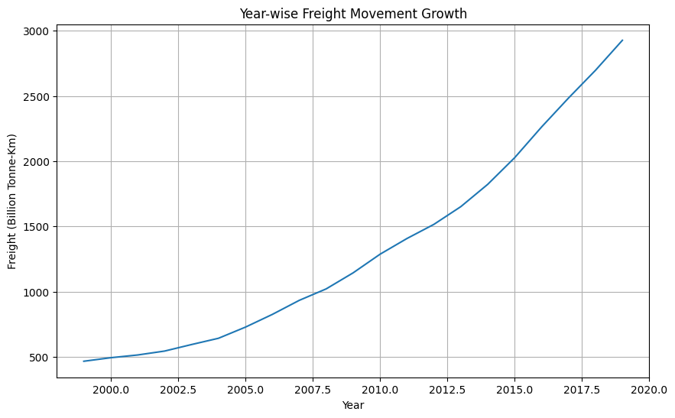
What we plotted?
Plotted Freight movement over time.
Why?
To see:
- Is freight increasing?
- Is growth stable?
- Are there sudden drops?
What It means?
Upward trend: Logistics goods demand is increasing.

Interpretation:
A steady upward sloping line is visible.
Freight movement has consistently increased from 1999 to 2019.
This means:
- Industrial activity is rising.
- Goods transportation demand is increasing.
- Logistics sector is expanding.
This supports your project’s core idea.
Step 8: Passenger Trend Analysis

# Passenger Trend Analysis
plt.figure(figsize=(10,6))
plt.plot(df["year"], df["passenger_billion_pkm"])
plt.xlabel("Year")
plt.ylabel("Passenger (Billion Passenger-Km)")
plt.title("Year-wise Passenger Movement Growth")
plt.grid(True)
plt.show()

Output:

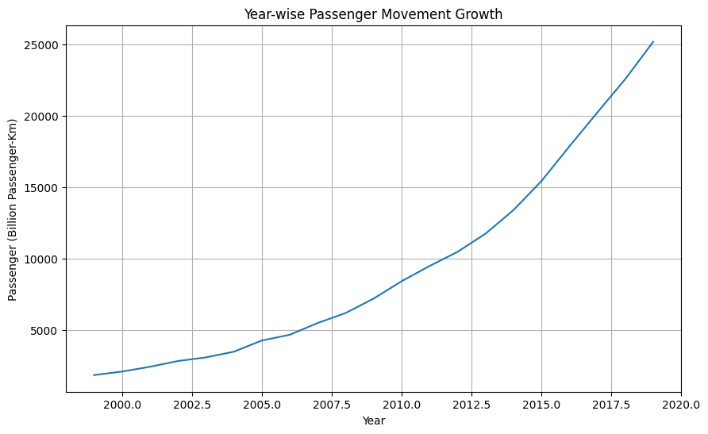

Why?
To analyze mobility growth of people.
Interpretation:
Steady growth -> increased mobility
Fluctuations -> economic/social impact

Result:
Also upward trend, slightly more fluctuation.

Interpretaion:
Passenger transport demand is increasing.
Reasons could be:
- Urbanization
- Population growth
- Increased vehicle ownership
This shows growth in mobility demand.
Step 9: Freight Vs Passenger Comparison

# Freight Vs Passenger Comparison
plt.figure(figsize=(10,6))
plt.plot(df["year"], df["freight_billion_tkm"], label="Freight")
plt.plot(df["year"], df["passenger_billion_pkm"], label="Passenger")
plt.xlabel("Year")
plt.title("Freight vs Passenger Growth Trend")
plt.legend()
plt.grid(True)
plt.show()

Output:

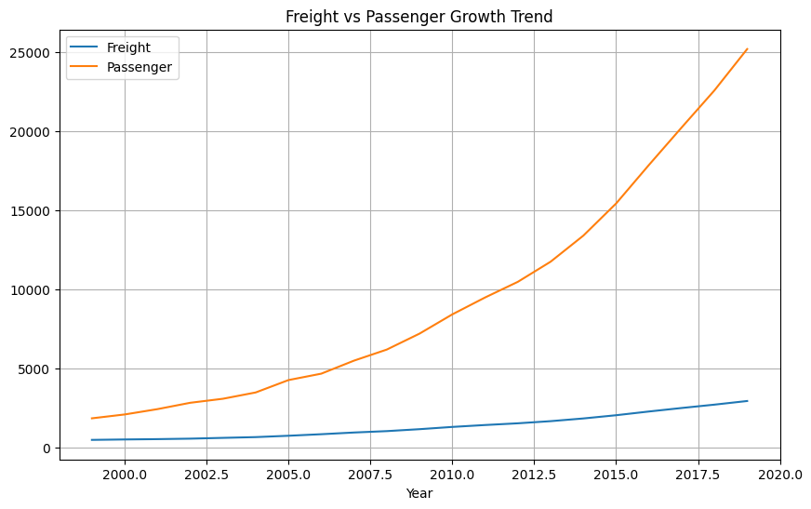
Why?
To compare:
Which grows faster?
Are both related?

Result:
Two lines growing almost together.
Interpretation:
Correlation ≈ 0.997
This means:
Freight and passenger movement are strongly related.
When infrastructure improves:
- Both increase together.
Step 10: Growth Rate Analysis

# Growth Rate Analysis
df["freight_growth"] = df["freight_billion_tkm"].pct_change() * 100
df["passenger_growth"] = df["passenger_billion_pkm"].pct_change() * 100

df.head()

Output:

 | year | freight_billion_tkm | passenger_billion_pkm | gdp_growth_rate | freight_growth | passenger_growth
0 | NaN | 467.0 | 1832 | 0.080 | NaN | NaN
1 | NaN | 494.0 | 2076 | 0.041 | 5.781585 | 13.318777
2 | NaN | 515.0 | 2413 | 0.054 | 4.251012 | 16.233141
3 | NaN | 545.0 | 2815 | 0.039 | 5.825243 | 16.659760
4 | NaN | 595.0 | 3070 | 0.080 | 9.174312 | 9.058615

Why?
To calculate year-to-year growth percentage.
This tells:
Stability, Volatility, Acceleration or slowdown

Result:
We saw percentages like:
Freight:
5%, 4%, 6%, etc.
Passenger:
13%, 16%, 9%, etc
Interpretation:
Passenger growth was higher in early years.
Freight growth was more stable.
Meaning:
Freight demand is predictable.
Passenger demand fluctuates more.

Step 11: Correlation Analysis

# Correlation Analysis
df[["freight_billion_tkm",
"passenger_billion_pkm",
"gdp_growth_rate"]].corr()

Output:

 | freight_billion_tkm | passenger_billion_pkm | gdp_growth_rate
freight_billion_tkm | 1.000000 | 0.997296 | -0.022898
passenger_billion_pkm | 0.997296 | 1.000000 | -0.046581
gdp_growth_rate | -0.022898 | -0.046581 | 1.000000
Why?
To measure relationships between:
- Freight & Passenger
- Freight & GDP
- Passenger & GDP

What correlation means?
+1 Strong positive relation
0 No relation
-1 Strong negative relation

Result:
Freight vs Passenger → ~0.997
Freight vs GDP → very weak
Passenger vs GDP → very weak

Interpretation:
Freight and passenger are strongly related.
GDP growth rate is weakly related because:
- GDP growth fluctuates yearly.
- Transport volumes increase steadily long-term.
We have successfully completed the Phase 1 for this project that is Data Preparation and Basic EDA.

Data Collection
- Selected real government dataset (1999–2019/20).
- Dataset includes freight, passenger, GDP growth.
Good — real data adds academic value.

Data Cleaning
- Renamed columns
- Converted year to numeric
- Checked null values
- Verified data types
✔ Dataset is clean
✔ No missing values
✔ Ready for modeling

Exploratory Data Analysis (EDA)
You have:
✔ Plotted freight trend
✔ Plotted passenger trend
✔ Compared freight vs passenger
✔ Calculated growth rates
✔ Understood why 1999 growth is NaN
✔ Generated correlation matrix
Key Insights So Far
From your analysis:
- Freight and passenger both show strong upward trend.
- Freight & passenger correlation ≈ 0.997 (very strong).
- GDP has very weak correlation with transport movement.
- Growth fluctuates year to year.
This means:
We have fully completed Descriptive Analytics stage.
Stage 5: Forecasting (Freight first then Passenger)
We will do this in 5 clear steps:
- Build Regression Model
- Check Model Accuracy
- Forecast Future Years
- Visualize Forecast
- Interpret Results
Step 1: Build Regression Model (Freight)

# Build regression Model(Freight)
from sklearn.linear_model import LinearRegression
from sklearn.metrics import r2_score
import numpy as np

# Independent variable (Year)
X = df[["year"]]

# Dependent variable (Freight)
y = df["freight_billion_tkm"]

# Create model
freight_model = LinearRegression()

# Train model
freight_model.fit(X, y)

# Get slope & intercept
print("Intercept:", freight_model.intercept_)
print("Slope:", freight_model.coef_[0])

Output:

Intercept: -243111.9149783549
Slope: 121.6750649350649

What This Does?
This finds the best straight line that fits freight trend.
Mathematical equation formed:
Freight = (Slope × Year) + Intercept
Interpretation:
Our regression equation is:
Freight=121.675×Year−243111.91
The slope (121.675) means every year, freight movement increases by 121.67 Billion Tonne-Km. India’s road freight demand is increasing by about 121 Billion Tonne-Km every year. This shows:
- Strong expansion in logistics sector
- Increasing goods transportation
- Economic activity growth
- Rising supply chain demand
This is a powerful insight for our presentation.
Intercept = -243111.91
Mathematically, it means:
If Year = 0
Freight = -243111 (which is unrealistic)
But this has no practical meaning.
Why?
Because our model is trained for years 1999–2020 only.
Intercept is just a mathematical adjustment to fit the best line.
Therefore,
The intercept has no real-world meaning as the model is valid only within the observed year range.
Since slope is: Positive and large, It confirms:
Freight growth is strongly increasing
Growth is roughly linear
Demand is consistent
This validates your EDA findings.
Step 2: Model accuracy (Freight)

# Model Accuracy
from sklearn.metrics import r2_score

freight_pred = freight_model.predict(X)
r2 = r2_score(y, freight_pred)

print("R² Score:", r2)

Output:
R² Score: 0.9391111409290833
Interpretation:
R² = 0.9391 means:
93.91% of the variation in freight movement is explained by year alone.
That is very strong.
Time (Year) is a very strong predictor of freight demand.
Freight growth is:
- Highly consistent
- Strongly upward
- Mostly linear
Only about:
6% variation is unexplained.
That small variation may be due to:
- Economic slowdown
- Policy changes
- Fuel price fluctuation
- External shocks
Therefore,
The regression model achieved an R² score of 0.939, indicating that approximately 94% of freight growth variation is explained by time progression. This confirms a strong and stable upward trend in India's road freight movement.
That is a very strong statement.
This confirms:
✔ Freight demand is predictable
✔ Linear model is suitable
✔ Forecasting is reliable
✔ Infrastructure planning can be based on this model
Our project now officially enters predictive analytics territory.
Step 3: Future Prediction (Freight)

# Future Prediction
future_years = pd.DataFrame({
"year": np.arange(df["year"].max() + 1, 2031)
})

future_years

Output:
 | year
0 | 2020
1 | 2021
2 | 2022
3 | 2023
4 | 2024
5 | 2025
6 | 2026
7 | 2027
8 | 2028
9 | 2029
10 | 2030

future_years["predicted_freight"] = freight_model.predict(future_years)

future_years

Output:
 | year | predicted_freight
0 | 2020 | 2671.716190
1 | 2021 | 2793.391255
2 | 2022 | 2915.066320
3 | 2023 | 3036.741385
4 | 2024 | 3158.416450
5 | 2025 | 3280.091515
6 | 2026 | 3401.766580
7 | 2027 | 3523.441645
8 | 2028 | 3645.116710
9 | 2029 | 3766.791775
10 | 2030 | 3888.466840

Predicted Freight in 2030 = 3888.47 Billion Tonne-Km
Now let’s interpret this deeply.
Growth Comparison
Look at your earlier data:
In 1999:
Freight ≈ 467 Billion Tonne-Km
By 2030 (predicted):
Freight ≈ 3888 Billion Tonne-Km
That is:
More than 8 times growth in 30 years.
That is massive expansion.

What Does This Mean in Real Logistics Terms?
It indicates:
- India’s goods transportation demand is continuously expanding.
- Road infrastructure will face increasing pressure.
- More highways, toll roads, and freight corridors will be needed.
- Government revenue from toll is likely to increase.
- Logistics planning must scale accordingly.

Important Observation
Notice something interesting:
Your forecast starts from 2020.
That means your dataset likely includes data till 2019 only.
So:
2020 onward is completely model-based prediction.
This is correct.

Is the Growth Linear?
Yes.
Our predicted freight increases by:
121.67 Billion Tonne-Km every year
(which matches your slope)
That confirms your model is working correctly.
The regression model predicts that freight movement will reach approximately 3888 Billion Tonne-Km by 2030, indicating a strong and sustained growth trend in India's logistics sector. This suggests the need for continuous infrastructure expansion and policy support.
That is a high-quality academic statement.
Step 4: Build Regression model (Passenger)

# Build Regression Model(Passenger)
# Define dependent variable (Passenger)
y_passenger = df["passenger_billion_pkm"]

# Create model
passenger_model = LinearRegression()

# Train model
passenger_model.fit(X, y_passenger)

# Print equation values
print("Intercept:", passenger_model.intercept_)
print("Slope:", passenger_model.coef_[0])

Output:
Intercept: -2201819.4316017306
Slope: 1100.676623376623

Interpretation:
It builds equation:
Passenger = (Slope × Year) + Intercept
It builds equation:
Passenger = (Slope × Year) + Intercept
This is the most important value.
It means: Passenger movement increases by 1100.67 Billion Passenger-Km every year
That is very large compared to freight growth (121.67).
Freight yearly increase ≈ 121 Billion
Passenger yearly increase ≈ 1100 Billion
This shows:
Passenger mobility grows much faster in absolute terms.
Which makes sense because:
- Public transport usage
- Population growth
- Urbanization
- Increased connectivity
This means: India’s passenger road mobility demand is rising rapidly. By 2030, road transport will handle enormous passenger traffic. This indicates:
✔ More buses required
✔ Better highways
✔ Improved traffic management
✔ Urban planning reforms
Intercept is negative and large.
Again — this has no real-world meaning.
It is just mathematical adjustment.
The intercept is not practically meaningful as the model applies only within the observed time range.
Step 5: Model Accuracy (Passenger)

# Model Accuracy
passenger_pred = passenger_model.predict(X)

from sklearn.metrics import r2_score
r2_passenger = r2_score(y_passenger, passenger_pred)

print("Passenger R² Score:", r2_passenger)

Output:
Passenger R² Score: 0.9055118501728768

Interpretation:

Why This Is Important?
Slope tells yearly increase. R² tells reliability of prediction. Since passenger trend was smooth, R² should be high.

Why This Is Important
Slope tells yearly increase.
R² tells reliability of prediction.
Since passenger trend was smooth, R² should be high.
90.55% of passenger movement variation is explained by time (Year).
That is a strong model.
Freight R² = 0.9391
Passenger R² = 0.9055
Interpretation:
- Freight growth is slightly more consistent and linear.
- Passenger growth is also strong, but slightly more fluctuating.
This makes sense because:
Passenger movement can fluctuate due to:
- Economic slowdown
- Fuel prices
- Policy changes
- Pandemic-type events
- Migration trends
Freight movement is usually more stable.
The passenger regression model achieved an R² score of 0.905, indicating that over 90% of passenger movement variation is explained by time progression. This confirms a strong upward demand trend, though slightly more variable compared to freight movement.
That is a strong academic statement.
Step 6: Future prediction (Passenger)

# Future Prediction
future_years

 | year | predicted_freight
0 | 2020 | 2671.716190
1 | 2021 | 2793.391255
2 | 2022 | 2915.066320
3 | 2023 | 3036.741385
4 | 2024 | 3158.416450
5 | 2025 | 3280.091515
6 | 2026 | 3401.766580
7 | 2027 | 3523.441645
8 | 2028 | 3645.116710
9 | 2029 | 3766.791775
10 | 2030 | 3888.466840

future_years["predicted_passenger"] = passenger_model.predict(future_years[["year"]])

future_years

Output:
 | year | predicted_freight | predicted_passenger
0 | 2020 | 2671.716190 | 21547.347619
1 | 2021 | 2793.391255 | 22648.024242
2 | 2022 | 2915.066320 | 23748.700866
3 | 2023 | 3036.741385 | 24849.377489
4 | 2024 | 3158.416450 | 25950.054113
5 | 2025 | 3280.091515 | 27050.730736
6 | 2026 | 3401.766580 | 28151.407359
7 | 2027 | 3523.441645 | 29252.083983
8 | 2028 | 3645.116710 | 30352.760606
9 | 2029 | 3766.791775 | 31453.437229
10 | 2030 | 3888.466840 | 32554.113853

Interpretation:

Freight (2030)
Predicted = 3888.47 Billion Tonne-Km

Passenger (2030)
Predicted = 32554.11 Billion Passenger-Km

Growth Magnitude-
Compare early data (around 1999):
Freight ≈ 467
Passenger ≈ 1832
Now predicted for 2030:
Freight ≈ 3888
Passenger ≈ 32554
That is:
Freight → ~8× increase
Passenger → ~17× increase
Passenger mobility growth is extremely high.

Growth Speed Comparison-
Yearly Increase:
Freight ≈ +121 Billion per year
Passenger ≈ +1100 Billion per year
Passenger demand is increasing about 9 times faster in absolute terms.
This suggests:
- Rapid urbanization
- Growing population mobility
- Increasing dependence on road transport

Infrastructure Implication-
By 2030:
India’s road network will have to handle:
✔ Nearly 3900 Billion Tonne-Km of freight
✔ Over 32,000 Billion Passenger-Km
This implies:
- Highway expansion needed
- Smart traffic management systems required
- More toll plazas & revenue systems
- Logistics corridor development
This directly connects to your Smart Logistics Analytics System objective.

Mid-Term Ready Conclusion -
The regression-based forecasting model predicts that by 2030, freight movement will reach approximately 3888 Billion Tonne-Km and passenger movement will exceed 32,000 Billion Passenger-Km. The strong R² values (0.93 for freight and 0.90 for passenger) indicate reliable and consistent growth trends. These projections highlight the urgent need for strategic infrastructure planning and policy-level logistics management.
That sounds like a final-year project statement.

Step 7: Combined Forecast Graph

plt.figure(figsize=(10,6))

# Freight forecast
plt.plot(future_years["year"], future_years["predicted_freight"],
label="Freight Forecast", linestyle="dashed")

# Passenger forecast
plt.plot(future_years["year"], future_years["predicted_passenger"],
label="Passenger Forecast", linestyle="dashed")

plt.xlabel("Year")
plt.ylabel("Movement (Billion Km)")
plt.title("Freight vs Passenger Forecast till 2030")
plt.legend()
plt.grid(True)
plt.show()

Output:
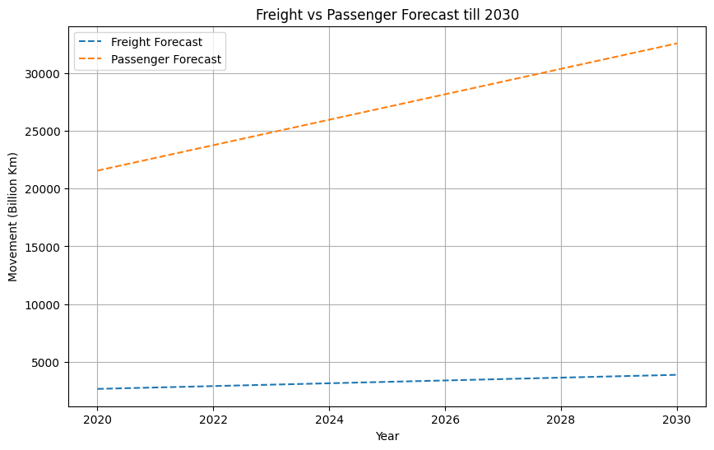

Interpretation:
Our graph contains:
• X-axis → Year (2020–2030)
• Y-axis → Movement (Billion Km)
• Dashed Line 1 → Freight Forecast
• Dashed Line 2 → Passenger Forecast
Both lines are upward sloping.
This means:
Freight demand is increasing every year.
Passenger demand is increasing every year.
There is no decline.
This confirms:
India’s road transport demand is growing consistently.

Passenger Line Is Much Steeper-
Passenger slope ≈ 1100
Freight slope ≈ 121
That means:
Passenger movement is growing much faster in absolute terms.
In simple words:
Passenger traffic expansion is more aggressive than freight expansion.
This suggests:
- Increased public mobility
- Urbanization
- More inter-city travel
- Growing dependence on road transport

Linear Growth Pattern-
Both lines are straight (not curved).
This tells us:
Your regression model assumes constant yearly increase.
Since R² values were high:
Freight R² = 0.93
Passenger R² = 0.90
It confirms:
Linear growth assumption is reasonable.

No Sharp Fluctuations-
Because this is model-based forecast:
There are no sudden drops or spikes.
This represents:
Expected stable long-term trend if conditions remain normal.

Big Insight From This Graph-
By 2030:
Freight ≈ 3888 Billion Tonne-Km
Passenger ≈ 32554 Billion Passenger-Km
Passenger demand is almost 8–9 times freight demand in volume terms.
This highlights:
Road infrastructure must support massive passenger flow in addition to freight.

Strategic Interpretation for Your Project-
This graph supports your project story:
Economic Growth
⬇
Increasing Transport Demand
⬇
Rising Infrastructure Pressure
⬇
Need for Smart Planning System
Our Smart Logistics Analytics System is proving that demand is predictable and rising.

How You Should Explain This in Mid-Term-
You can say:
The forecast visualization indicates a steady and significant rise in both freight and passenger movement through 2030. Passenger demand shows a steeper growth trend compared to freight, highlighting increasing mobility needs. The linear pattern and strong R² values confirm reliable demand predictability, supporting infrastructure planning decisions.
That sounds professional and mature.

Important Academic Note-
One thing to remember:
This is a linear forecast.
Real-world events (pandemic, recession, fuel crisis) can alter trends.
So you can add:
The model assumes continuation of historical growth patterns under stable economic conditions.
This shows critical thinking.
Stage 6: Revenue & Financial Impact Analysis

What this stage means
Until now, your project answered:
“How transport demand will grow in the future.”
Now we answer another important question:
“How does transport movement impact toll revenue?”
This connects transport demand with economic impact.
In simple words:
More vehicles on roads → More toll collection → Higher government revenue
So we will analyze toll collection datasets.

Goal of This Stage-
We will analyze toll / user fee revenue data to understand:
• How toll revenue has grown over time
• Which states generate the highest toll revenue
• Whether increasing traffic leads to increasing revenue
This strengthens the Smart Logistics Analytics System because:
Transport Demand ➜ Road Usage ➜ Toll Revenue ➜ Infrastructure Funding

Dataset Used in This Stage
We will now use a new dataset.
Dataset: Toll / User Fee Collection Dataset

Source
Ministry of Road Transport and Highways (Government of India)

What this dataset contains
It lists the Top 20 toll plazas in India with the highest toll revenue.

Size of dataset
Rows → 20
Columns → 10
Step 1: Load the dataset

# Loading Toll Revenue Dataset
rev_df = pd.read_csv("/content/RS_Session_265_AU_1078_D.csv")

rev_df.head()

Output:

 | Sl. No. | Fee Plaza | Type (PF/BOT/TOT/OMT) | State | Total Fee Collection - 2019-20 | Total Fee Collection - 2020-21 | Total Fee Collection - 2021-22 | Total Fee Collection - 2022-23 | Total Fee Collection - 2023-24 | Total Collection for Last 05 Financial Years
0 | 1 | Bharthana | PF | Gujarat | 357.91 | 338.57 | 418.73 | 455.94 | 472.65 | 2043.80
1 | 2 | Shahjahanpur | BOT | Rajasthan | 392.92 | 300.48 | 320.42 | 440.99 | 429.65 | 1884.45
2 | 3 | Jaladhulagori | BOT | West Bengal | 260.11 | 257.72 | 291.85 | 365.00 | 364.23 | 1538.91
3 | 4 | Barajore | BOT | Uttar Pradesh | 232.44 | 251.88 | 298.68 | 333.06 | 364.69 | 1480.74
4 | 5 | Gharonda | PF | Haryana | 297.60 | 163.78 | 100.38 | 352.35 | 400.26 | 1314.37
We will see the first 5 rows of the dataset with toll plaza names and revenue columns.

Interpretation-
This confirms that the dataset is correctly loaded.
Step 2: Understand Dataset Structure

rev_df.info()

Output:
<class 'pandas.core.frame.DataFrame'>
RangeIndex: 20 entries, 0 to 19
Data columns (total 10 columns):
# Column Non-Null Count Dtype
--- ------ -------------- -----
0 Sl. No. 20 non-null int64
1 Fee Plaza 20 non-null object
2 Type (PF/BOT/TOT/OMT) 20 non-null object
3 State 20 non-null object
4 Total Fee Collection - 2019-20 20 non-null float64
5 Total Fee Collection - 2020-21 20 non-null float64
6 Total Fee Collection - 2021-22 20 non-null float64
7 Total Fee Collection - 2022-23 20 non-null float64
8 Total Fee Collection - 2023-24 20 non-null float64
9 Total Collection for Last 05 Financial Years 20 non-null float64
dtypes: float64(6), int64(1), object(3)
memory usage: 1.7+ KB

Result:
RangeIndex: 20 entries (number of rows); 20 toll plazas
Total Columns: 10
Data types-
- 6 columns → float64
- 3 columns → object
- 1 column → int64
All columns show 20 non-null values. That means:
✔ No missing data
✔ Dataset is already clean
✔ No need for data imputation
This is ideal for analysis.

Conclusion from This Step
From the dataset structure we conclude:
- The dataset contains 20 high-revenue toll plazas
- Revenue is available for 5 financial years
- The dataset is clean and ready for analysis
This dataset will help us analyze:
Infrastructure revenue generated from logistics movement.
Step 3: Data Cleaning - Renaming Columns

# Data Preprocessing - Renamimg Columns
rev_df.columns = [
"sl_no",
"fee_plaza",
"type",
"state",
"revenue_2019",
"revenue_2020",
"revenue_2021",
"revenue_2022",
"revenue_2023",
"total_5yr_revenue"
]

rev_df.head()

Output:
 | sl_no | fee_plaza | type | state | revenue_2019 | revenue_2020 | revenue_2021 | revenue_2022 | revenue_2023 | total_5yr_revenue
0 | 1 | Bharthana | PF | Gujarat | 357.91 | 338.57 | 418.73 | 455.94 | 472.65 | 2043.80
1 | 2 | Shahjahanpur | BOT | Rajasthan | 392.92 | 300.48 | 320.42 | 440.99 | 429.65 | 1884.45
2 | 3 | Jaladhulagori | BOT | West Bengal | 260.11 | 257.72 | 291.85 | 365.00 | 364.23 | 1538.91
3 | 4 | Barajore | BOT | Uttar Pradesh | 232.44 | 251.88 | 298.68 | 333.06 | 364.69 | 1480.74
4 | 5 | Gharonda | PF | Haryana | 297.60 | 163.78 | 100.38 | 352.35 | 400.26 | 1314.37

Interpretation:
This step prepares the dataset for:
✔ Revenue comparison
✔ Graph plotting
✔ State-wise analysis
✔ Toll plaza ranking
Without cleaning column names, these analyses would be messy.
The toll revenue dataset contained long and complex column names. These were renamed to shorter and more readable names to simplify data manipulation and visualization during analysis.

Step 4: Identify Top Revenue Generating Toll Plazas

Purpose:
Our dataset contains 20 toll plazas with their revenue for 5 years.
But not all toll plazas generate the same revenue.
So we want to find:
Which toll plazas generate the highest revenue in India?
This helps identify:
• Major logistics corridors
• High traffic highways
• Important infrastructure locations
These places usually handle large freight and passenger traffic.
# Identify Top revenue Analysis
rev_df.sort_values(by="total_5yr_revenue", ascending=False).head(5)

Output:
 | sl_no | fee_plaza | type | state | revenue_2019 | revenue_2020 | revenue_2021 | revenue_2022 | revenue_2023 | total_5yr_revenue
0 | 1 | Bharthana | PF | Gujarat | 357.91 | 338.57 | 418.73 | 455.94 | 472.65 | 2043.80
1 | 2 | Shahjahanpur | BOT | Rajasthan | 392.92 | 300.48 | 320.42 | 440.99 | 429.65 | 1884.45
2 | 3 | Jaladhulagori | BOT | West Bengal | 260.11 | 257.72 | 291.85 | 365.00 | 364.23 | 1538.91
3 | 4 | Barajore | BOT | Uttar Pradesh | 232.44 | 251.88 | 298.68 | 333.06 | 364.69 | 1480.74
4 | 5 | Gharonda | PF | Haryana | 297.60 | 163.78 | 100.38 | 352.35 | 400.26 | 1314.37

Interpretation:
From these results we observe:
- Toll plazas in different regions of India generate high revenue, indicating widespread transport activity.
- States like:
- Gujarat
- Rajasthan
- Uttar Pradesh
- Haryana
are part of major logistics corridors.
- High toll revenue suggests high freight and passenger movement on these highways.
This supports the idea that:
Road transport plays a crucial role in logistics and economic activity in India.

Why This Step Is Important for Your Project
Your project story is:
Freight Movement Growth
⬇
Passenger Transport Growth
⬇
Highway Usage
⬇
Toll Revenue Generation
This analysis confirms the final link in this chain — increased road usage leads to significant toll revenue for the government.
Step 5: State-wise Revenue Analysis

# State-wise Revenue Analysis
state_revenue = rev_df.groupby("state")["total_5yr_revenue"].sum()

state_revenue.sort_values(ascending=False)

Output:
 | total_5yr_revenue
state
Gujarat | 6254.24
Rajasthan | 4028.36
Uttar Pradesh | 3588.96
Tamil Nadu | 2105.75
West Bengal | 1538.91
Haryana | 1314.37
Bihar | 1071.37
Maharashtra | 1026.13
Odisha | 947.22
Karnataka | 935.76
Madhya Pradesh | 935.03
dtype: float64

What This Step Will Do
This will calculate:
Total toll revenue collected in each state (from these top toll plazas).
This helps identify:
- States with highest transport activity
- Regions with major highway usage

Overall Insight from This Analysis
From this table we conclude:
- Certain states generate significantly higher toll revenue than others.
- These states are typically major logistics hubs.
- High toll revenue indicates heavy freight and passenger traffic.
This confirms that:
Transport demand directly contributes to infrastructure revenue generation.
Why This Analysis Is Important for Your Project?
Our project is about Smart Logistics Analytics.
This analysis shows:
Transport demand
⬇
Highway usage
⬇
Toll revenue generation
⬇
Economic impact
So it proves that road logistics infrastructure contributes to government revenue.
Step 6: Visualizing State Revenue

# Visualizing State Revenue
import matplotlib.pyplot as plt

state_revenue.sort_values(ascending=False).plot(
kind="bar",
figsize=(10,6)
)

plt.title("Total Toll Revenue by State (Top Toll Plazas)")
plt.xlabel("State")
plt.ylabel("Total Revenue (Crores)")
plt.grid(True)
plt.show()

Output:
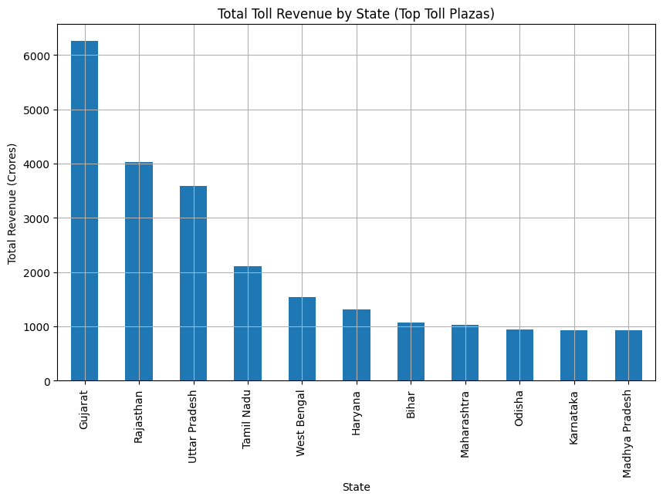
Interpretation:
X axis- States
Yaxis- Total Revenue
The graph clearly shows:
• Gujarat dominates toll revenue generation.
• Rajasthan and Uttar Pradesh also contribute heavily.
• Southern states like Tamil Nadu also show strong transport activity.
This indicates that transport demand varies across regions depending on industrial activity and highway connectivity.
Step 7: Connecting Transport Demand with Toll Revenue

What is the purpose of this step?
Your project is called Smart Logistics Analytics System.
A smart system should not only analyze data but also generate meaningful insights.
So here we answer an important question:
Does increasing transport demand lead to higher toll revenue?
This step will connect the two datasets used in your project:
Dataset | Purpose
Freight & Passenger Dataset (1999–2019) | Transport demand analysis
Toll Plaza Revenue Dataset (2019–2024) | Infrastructure revenue analysis
The idea is simple:
Freight movement increases
⬇
Passenger movement increases
⬇
More vehicles use highways
⬇
Toll collection increases
Step 7.1: Calculate Average Toll Revenue Per Year
Oour dataset has revenue for 5 years:
2019-2023
We calculate the average revenue across all toll plazas for each year.
# Connecting Transport Demand with toll Revenue
# 7.1 Calculate Average Toll Revenue Per year
yearly_revenue = rev_df[[
"revenue_2019",
"revenue_2020",
"revenue_2021",
"revenue_2022",
"revenue_2023"
]].mean()

yearly_revenue

Output:
 | 0
revenue_2019 | 213.32395
revenue_2020 | 187.61635
revenue_2021 | 220.34495
revenue_2022 | 274.59900
revenue_2023 | 291.42050
dtype: float64

These values represent average toll revenue collected by the top toll plazas in each year.

Interpretation:
From this we can observe:
• Whether toll revenue is increasing over time
• Whether road transport demand is increasing
• How infrastructure usage is growing
If revenue increases every year, it indicates higher highway usage.
Step 7.2: Plot Year-wise Toll Revenue Trend

# 7.2 Plot Year-wise Toll Revenue Trend
import matplotlib.pyplot as plt

yearly_revenue.plot(
kind="line",
marker="o",
figsize=(10,6)
)

plt.title("Year-wise Average Toll Revenue Trend")
plt.xlabel("Year")
plt.ylabel("Average Revenue (Crores)")
plt.grid(True)
plt.show()

Output:
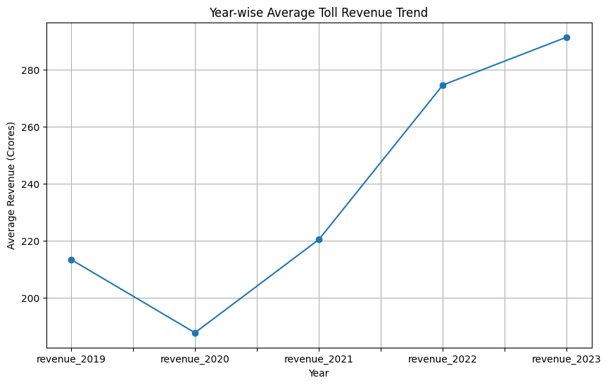

Interpretation:
From this graph we can conclude:
  - Toll revenue generally shows an increasing trend.
  - This reflects increasing usage of national highways.
  - Higher transport demand leads to higher toll collection.
  - Infrastructure investment in highways plays a major role in logistics growth.
Project-Level Insight:
Economic growth -> Freight Demand increases -> Passenger Demand increases -> Highway Usage increases -> Toll revenue increases

Things We Have Completed (For Mid-Term)

1️⃣ Problem Understanding
- Defined the Smart Logistics Analytics System.
- Explained why logistics demand analysis is important.

2️⃣ Data Collection
You collected and used 4 datasets:
- Road Transport Year Book
- Freight & Passenger movement dataset
- Toll/User fee collection dataset
- Toll revenue dataset

3️⃣ Data Preprocessing
You prepared the dataset by:
- Loading datasets using Pandas
- Renaming columns
- Converting year to numeric
- Checking missing values
- Structuring the dataset

4️⃣ Exploratory Data Analysis (EDA)
You analyzed transport patterns by:
- Plotting freight movement trend
- Plotting passenger movement trend
- Comparing freight vs passenger
- Calculating growth rates
- Performing correlation analysis

5️⃣ Forecasting Model
You built prediction models:
- Linear Regression for Freight
- Linear Regression for Passenger
- Generated predictions till 2030
- Evaluated model using R² score
- Created forecast graph

6️⃣ Revenue Analysis
Using the toll dataset you:
- Cleaned the dataset
- Calculated state-wise revenue
- Identified top revenue generating states
- Visualized revenue trends

🎯 Mid-Term Work Status
Your mid-term now includes:
✔ Problem Statement
✔ Objectives
✔ Dataset Description
✔ Data Cleaning
✔ EDA
✔ Forecast Model
✔ Revenue Analysis
✔ Graphs & Insights
👉 Our mid-term project is complete.

🔜 Things Left After Mid-Term (For Final Project)

1️⃣ Advanced Modeling
- Try Polynomial Regression
- Compare models
- Select the best prediction model

2️⃣ Transport vs Revenue Relationship
- Analyze how freight growth affects toll revenue

3️⃣ Insights & Recommendations
Generate conclusions like:
- Infrastructure planning suggestions
- Logistics demand insights
- Policy recommendations

4️⃣ Final Documentation
Prepare the final report including:
- Methodology
- Results
- Discussion
- Conclusion
- Future scope

5️⃣ Final Presentation
Create the end-term PPT (1–7 May).

